 

# ‘ who ‘ command

The main usage of **who** command in Linux without command-line parameter is to show the name of the users who are logged in currently.



# ‘ whoami ‘ command

The **whoami** command allows Linux users to see the currently logged-in user. The output displays the username of the effective user in the current shell.Additionally, **whoami** is useful in bash scripting to show who is running the script .



# ‘ cat ‘ command

The **cat** (concatenate) command is one of the most frequently used commands in Linux/Unix-like operating systems. **cat** command allows us to create single or multiple files, view content of a file, concatenate files and redirect output in terminal or files.

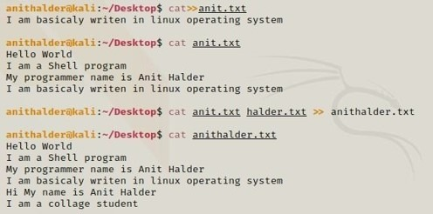

# ‘ mkdir ‘ command

The mkdir command in Linux allows users to create or make new directories. **mkdir** stands for ―make directory.‖ With **mkdir** , you can also set permissions, create multiple directories (folders) at once, and much more.

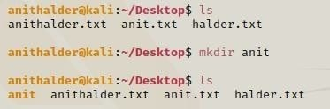

# ‘ rm ‘ command

The **rm** command removes the entries for a specified file, group of files, or certain select files from a list within a directory. User confirmation, read permission, and write permission are not required before a file is removed when you use the **rm** command.

-f **:** Forces the removal of all files or directories.

-i **:** Prompts for confirmation before removing.

-I **:** Prompts once before removing more than three files or when removing recursively.

-r **:** Removes directories and their content recursively.

-d **:** Removes empty directories.

-v **:** Provides a verbose output.

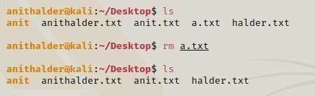

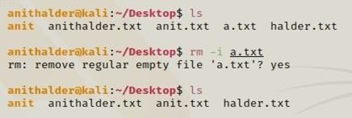

# ‘ rmdir ‘ command

**rmdir** command removes empty directories specified on the command line. These directories are removed from the filesystem in the same order as they are specified on the command line, i.e., from left to right. If the directory is not empty you get an error message.

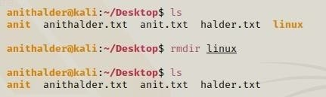

# ‘ mv ‘ command

The **mv** command to move files and directories from one directory to another or to rename a file or directory. If you move a file or directory to a new directory without specifying a new name, it retains its original name.

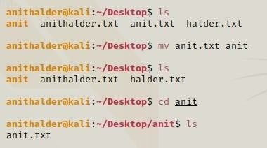

# ‘ cp ‘ command

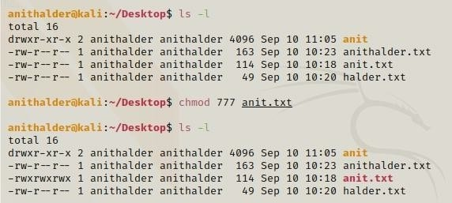We use the **cp** command for copying files from one location to another. This command can also copy directories (folders).

# ‘ ls ‘ command

The **ls** command is used to list files or directories in Linux and other Unix-based operating systems. Just like you navigate in your File explorer or Finder with a GUI, the **ls** command allows you to list all files or directories in the current directory by default, and further interact with them via the command line.

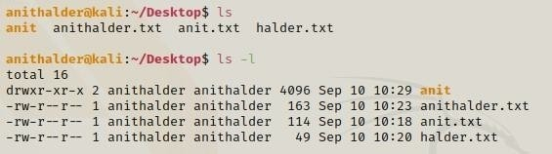

# ‘ wc ‘ command

The **wc** command in Linux is a command line utility for printing newline, word and byte counts for files. It can return the number of lines in a file, the number of characters in a file and the number of words in a file. It can also be combine with pipes for general counting operations.

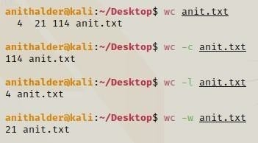

# ‘ pwd ‘ command

The **pwd** command writes to standard output the full path name of your current directory (from the root directory). All directories are separated by a **/** (slash). The root directory is represented by the first **/**, and the last directory named is your current directory.



# ‘ chmod ‘ command

The **chmod** (short for change mode) command is used to manage file system access permissions on Linux and Unix-like systems. There are three basic file system permissions, or modes, to files and directories: read (r) write (w).

* chmod +rwx filename to add permissions.

* chmod -rwx directoryname to remove permissions. * chmod +x filename to allow executable permissions. * chmod -wx filename to take out write and executable

permissions.



# ‘ expr ‘ command

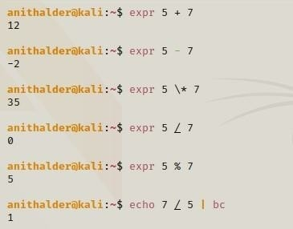**expr** is a command line Linux utility which evaluates an expression and outputs the corresponding value. **expr** evaluates integer or string expressions, including pattern matching regular expressions.

# ‘ echo ‘ command

**echo** command in linux is used to display line of text/string that are passed as an argument . This is a built in command that is mostly used in shell scripts and batch files to output status text to the screen or a file. In above example, text after

\c is not printed and omitted trailing new line.

